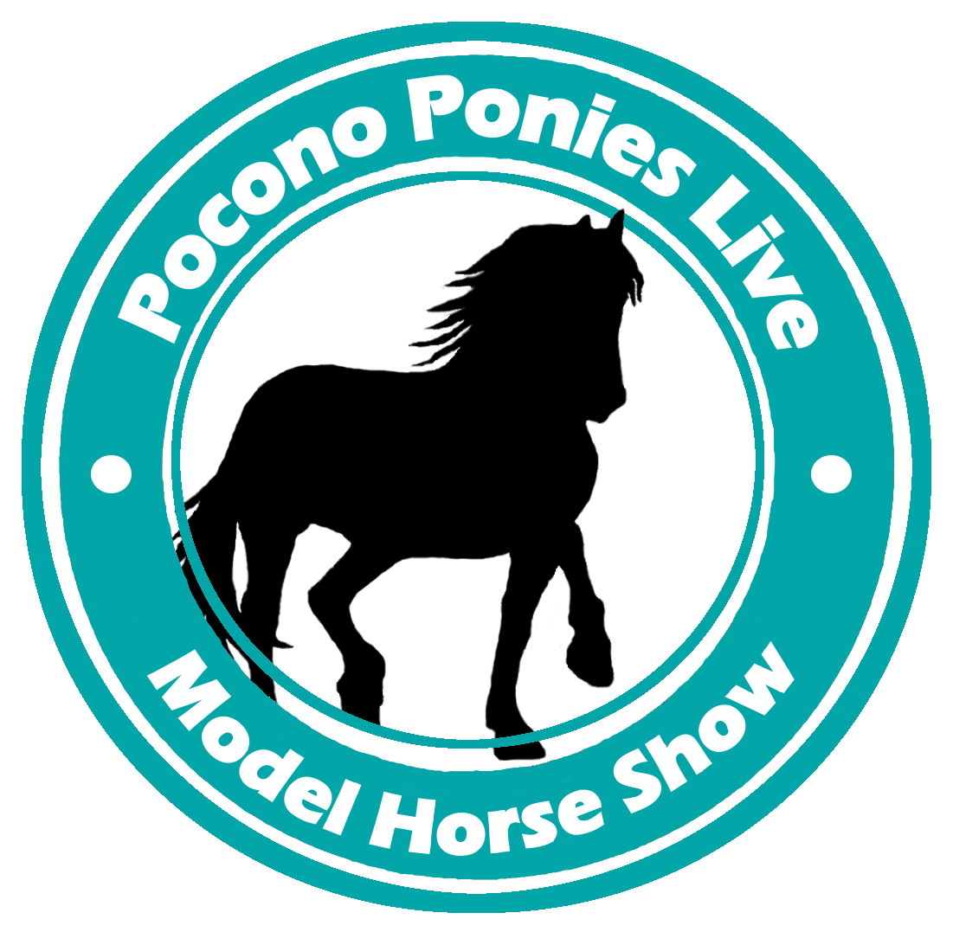

May 5th, 2018
Aquashicola Fire Hall
Palmerton, Pennsylvania
Pocono Ponies Live
A benefit show for Our Mims Retirement Haven!
NAMHSA Approved
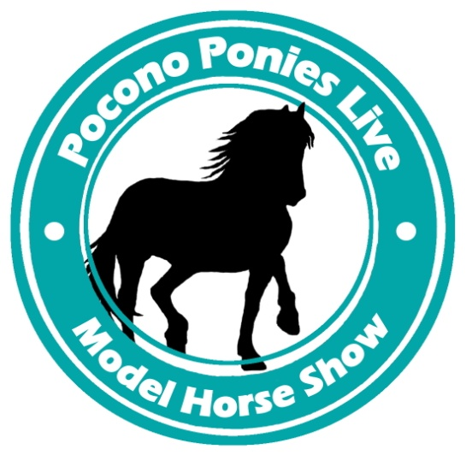
May 5th, 2018
www.poconoponieslive.weebly.com
Also, “Like” the show on Facebook!
https://www.facebook.com/poconoponieslive

Location:
Aquashicola Fire Hall
290 Little Gap Rd
Palmerton, PA 18071

Setup begins at 6:30am, judging is to begin promptly at 8:00am.

Entry Fees:
Half table: $40 Full table: $50
NAN cards awarded for first and second place equids in all NAN-qualifying classes.
Please note there is a limit of one full table per entrant.

Registration forms must be postmarked by April 21st, 2018. If you are sending in a form after this date please email me at geohorse@ptd.net to make sure there is space available. Registering after the due date will also incur an additional $10 late fee. We reserve the right to refuse entry once all tables have sold out. The website and Facebook page will also be updated as space becomes limited.

Awards:
- Paper ribbons for 1st through 6th place in all divisions
- Rosettes and candy for champions and reserves

Judging:
Horses that place first or second in all NAN qualifying classes will receive a NAN card. This card qualifies the horse to compete in the North American Nationals show for the following four years. Please respect judges’ opinions even if you disagree with them. All judges’ opinions are final. If you have a question about why your horse placed the way it did, you may ask the judge when they are not busy judging a class but while the class is still fresh in their mind. Arguing will not be tolerated. Judges reserve the right to split classes at their own discretion. Split classes will be announced so please listen carefully to the judge’s instructions.

Show tables:
Tables are not covered, it is recommended you bring your own table cover if you desire. Selling at your table is permitted, but keep in mind that this show is benefitting Our Mims. Please consider donating to the raffle and help save the horses! If you have a sign for sale items, please tape it to the table, not the wall. If you tape the sign to your table you are expected to peel the tape off at the end of the show. If you have a seating request, there is a section on the registration form for you to notate that. We will try our best to accommodate you. Requests for specific tables or sections of the hall will not be accepted.

Entry Limits:
2 horses per halter class 2 horses per performance class

If you wish to enter more horses than the limit, you may place a $1 donation to Our Mims next to each additional horse over the limit.

Proxy Showing:
Proxy is now available at Pocono Ponies Live! Wish to show some of your horses but can’t attend? Then proxy showing is for you! You are responsible for finding and communicating with someone to show your horses for you at the show and for paying full entry fees for each horse. Please do your research and make sure the person is trustworthy – we are not responsible for missing or damaged horses! Proxy fee is $3.00 per horse and a maximum of 10 horses. You will NOT receive table space for proxy, the person showing your horses will keep your horses on their table. Proxy is only available for the Open divisions.

Performance:
Due to limited table space, please keep your performance display to a maximum of 18”X 30” per entry (except harness). Please keep excessive props at a minimum. Dolls are not required for any class, but if they are used they must be correctly positioned and wearing appropriate attire. Horses being shown in a performance class are required to wear tack appropriate for the class. Only one horse may be toe tagged per entry. Any other horses will be considered props. The horse with the toe tag will be the one that is judged and receive a NAN card if placed first or second in the class. Each horse may show in either performance or in halter. Both divisions will be running at the same time, and a class will not be held up for one horse to be tacked/untacked.

Halter:
Halter classes will be judged on conformation, color, breed characteristics, paint job, prepping, and condition. No felt squares are permitted to be placed on the ring under the horse unless the horse is being shown lying down. Be aware that lying the horse down automatically gives the judge permission to pick up your horse to see the other side. If you are showing your horse this way, please do not attach the toe tag and simply lay it down next to the horse with the correct side facing up. This way the judge won’t see the owner’s name. If you do not want the judge to handle your model, please place a note by the horse and stand relatively close to the ring so you can turn the horse over when the judge asks. If your horse is “tippy” or falls over easily, it is best to lay it down so it won’t fall over and get damaged. Horses in the halter classes are not required to wear a halter, and it is greatly discouraged. However, molded-on tack is acceptable. If your horse is wearing a not molded-on halter, it must properly fit and be correct for the breed. Please refrain from leaving any other tack on a halter horse. One class per division per horse. This means you can’t show your horse in both British Pony and American Pony. However, you may show it in British Pony and the Bay/Black/Brown Jackpot class.

Toe Tags:
Each model is required to have a toe tag. The breed and gender is to be written on one side, with the shower’s name (or initials) and the horse’s name on the other side. When the horse is placed on the ring, the breed/gender side is to be facing upward. Double check your tag is facing the correct way! If your tag is facing the name side up, your horse risks disqualification. The Kids divisions will be more lenient, but please be careful whether you’re showing in Open or Kids. These tags can be purchased in any office store, such as Staples, or any store that sells office supplies. They are often sold as “strung marking tags.” If your horse is a cross breed, please note which two breeds are crossed, not just “Arabian cross,” but “Arabian/Paint Cross” for example. For grades please write what type of grade, such as “draft type grade,” or “light type grade.” Toe tags will not be supplied to you, please make sure all of your toe tags are filled out before the show.

Example:

“Abstract Holiday”

LJB
Spanish Mustang

Stallion

Definitions:
Original Finish (OF): No changes made to the model, it is exactly the way it was when it was inside the box. This includes all of the brands you know, such as Breyer, Peter Stone, Hartland, and even brands like CollectA, Schleich, and Safari Ltd.
Custom (CM): The model has been altered in some way, such as repainted, rehaired, repositioned, resculpted, etched, et cetera.
Artist Resin (AR): Original sculptures that are cast in resin and painted by an artist. Resin models that were painted in a factory (such as Breyer Breed of the World resins) are not ARs and show in the OF division.
Mini: All horses smaller than Classic scale, such as Stablemates, Chips, Pebbles, Paddock Pals, and micro minis.

Documentation:
Documentation is not required in any class, but it is encouraged for rare/unusual breeds or unusual colors within a breed. Please limit your documentation to one sheet of 8½” x 11” paper or smaller. Common breeds and colors do not require documentation.

Rings:
Open Performance, OF Halter, OF Breyer/Other Mini, and OF Stone Mini will all be running at the same time when the show starts. The next divisions will pick up when these divisions are finished. Each ring will be labeled with the ring number and divisions running in each ring. Please stay alert and pay attention to which classes are being called. This keeps the show running smoothly.

Example:
(Please note this is just an example, these divisions may not actually be in these ring numbers.)
Ring 1 – OF Halter - OF Sport, Class 20: Thoroughbred– Breyer/Other
Ring 2 – AR Halter – Class 116. Thoroughbred/Standardbred
Ring 3 –OF Mini Breyer/Other Halter, Class 74: Sport-Solid
Ring 4 – Performance, Class 1: Harness/Driving
Callbacks:
At the judges’ discretion, they will call back either first place horses only or both first and second place horses at the end of each division. The judge will then decide the champion and reserve champion of the division from these horses. At the end of all of the divisions in each parent division, all of the champions will be called back and the overall champion will be decided for the parent division. Divisions with an overall champion are notated in the class list. NAN cards do not need to be brought back up with the horse, only the ribbons won.

Unloading/Loading:
The parking lot is only a few feet away from the door. You may unload at your at the side door car and simply walk into the building. Please do not block the fire doors or park wherever there is a “No parking” sign. There is plenty of parking available. Please do not park along the street. Please do not use the front doors.

Raffle:
There will be a raffle for this show, with all proceeds going to Our Mims. Tickets are $1 each or 6 for $5. Please write your name on the back of the ticket – we will not be drawing by number! All donations are appreciated! If you have something to donate please email geohorse@ptd.net.

General Rules and Guidelines:
Please do not place books on the rings for your documentation. If you need to document something you must use a piece of paper or an index card. If you are not sure what class a model should be shown in, please ask the showholder or the judge well before the class starts.
We ask that you refrain from running in the show hall. Do not touch any models without asking the owner. No alcohol, foul language, pets, or radios permitted in the hall. Please refrain from lingering near the show rings while judging is in progress, and please try your best not to talk when the judge is judging a class.
All of your belongings must be stored on or under your table, not in the walkway. There will be no refunds for any reason. This is a benefit show and all proceeds will be donated to Our Mims Retirement Haven.
Please listen carefully to the judges’ announcements. This show runs very quickly and it is easy to miss classes. Have your horses tagged and ready to bring up to the ring when the class is called.

Directions:
Starting out heading eastward on Interchange Rd/US 209 toward Harrity Rd
Turn Right onto Forest Inn Rd
Turn Left onto Little Gap Rd
The fire hall is on your left
Starting out heading northward on PA-33, take the first left onto PA-611
Make a sharp left. If you reach Cruver Ave you've gone about 0.2 miles too far
Take the exit toward Saylorsburg
Keep right to take the ramp toward Saylorsburg/Bossardsville
Merge onto SR 2002/Wilkes Barre Turnpike
Turn left onto Kunkletown Rd/PA-335/SR 2002. Continue to follow SR 2002. SR 2002 is just past Herbst St. Sunoco Service Station is on the corner. If you are on Wilkes Barre Turnpike and reach A2734 you've gone a little too far.
SR 2002 becomes Little Gap Rd
The fire hall is on your right

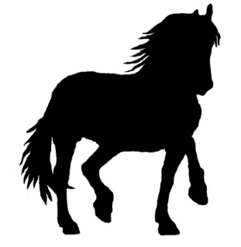
Pocono Ponies Live Registration Form
May 5th, 2018
Please print legibly or type

Shower’s Name: _________________________________________________________

Address: ________________________________________________________________

Phone Number: __________________________________________________________

Email Address: __________________________________________________________
Initials on toe tags (if not full name)

_____ _______ _______
(First) (Middle) (Last)

Half Table ($40) _____
Full Table ($50) _____
Total _____

I would like to be seated next to/near (if possible): _________________________________________________

Please circle the division(s) you will be mainly showing in:

Performance OF Halter OF Breyer/Other Mini OF Stone Mini CM Mini AR Mini AR Halter CM Halter

Please mail your registration form to:
LeeAnn Bachman
Questions?
Email LeeAnn at geohorse@ptd.net
441 Frable Drive
Kunkletown, Pennsylvania 18058
Please make checks payable to:
LeeAnn Bachman
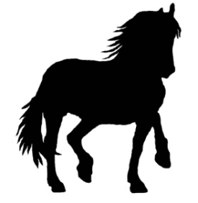
Pocono Ponies Live
May 5th, 2018
Open Division Proxy Showing Registration Form
Proxy is now available at Pocono Ponies Live! Wish to show some of your horses but can’t attend? Then proxy showing is for you! You are responsible for finding and communicating with someone to show your horses for you at the show and for paying full entry fees for each horse. Please do your research and make sure the person is trustworthy – we are not responsible for missing or damaged horses! Proxy fee is $3.00 per horse and a maximum of 10 horses. You will NOT receive table space for proxy, the person showing your horses will keep your horses on their table. Proxy is only available for the Open divisions.
Please print legibly or type

Name: ____________________________________________________

Address: ________________________________________________________________

Phone Number: __________________________________________________________

Email Address: __________________________________________________________
Initials on toe tags (if not full name)

_____ _______ _______
(First) (Middle) (Last)

Number of horses: ______________

Entry fee paid: $_______________

Name of exhibitor showing your horses: _______________________________________

Please mail your registration form to:
LeeAnn Bachman
Questions?
Email LeeAnn at geohorse@ptd.net
441 Frable Drive
Kunkletown, Pennsylvania 18058
Please make checks payable to:
LeeAnn Bachman

